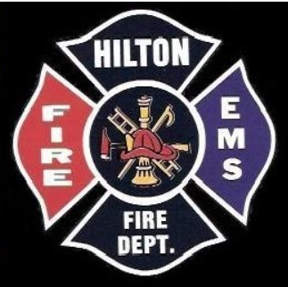

**Hilton Fire Department**

**120 Old Hojack Lane**

**Open House**

**Saturday, Sept. 23th**

**12:00 Noon til 3:00 pm**

**Tours and Demonstrations including:**

* Fire Apparatus Displays
* Missing & Exploited Children
* Fire Extinguisher
* Sparky the Fire Dog
* Jaws of Life Demonstration
* American Red Cross

*Win a Ride to School on a Firetruck!*

(see back for details)



